How to update the ESP8266 Module's firmware

**BEFORE YOU BEGIN** Note that this information has been cobbled together from multiple websites and the official [Espressif AT Github Repository](https://github.com/espressif/esp8266_at). It worked for me, and may work for you, but I take no responsibility if your ESP8266 module stops working after attempting this.

Required hardware and software

* You will need a Windows PC for this update
* You will need some form of USB to Serial converter that allows operation at 3.3V. I used a [Foca](http://imall.iteadstudio.com/im120525005.html) board. It allows easy plugging into a breadboard, which then allows me to hookup the pins of the ESP8266 module via jumper wires to the corresponding pins on the USB<->Serial board.
* The firmware updating software only works on COM ports **1-6**. If your USB<->Serial device enumerates to a higher port number than that, you will have to change it via *Device Manager* in Windows.
* You can download all the required files in this ZIP file [esp_flasher.zip](https://os.mbed.com/media/uploads/sschocke/esp_flasher.zip)

Connecting it up

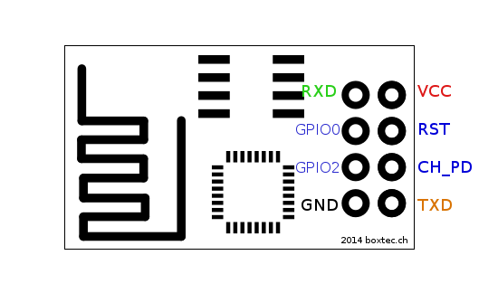

Above is a pin out diagram for the ESP8266 Module

You need to hookup these pins from the ESP8266 to your USB<->Serial board:

* VCC to 3.3V
* GND to ground
* CH_PD to 3.3V
* TXD to RX, RXD to TX *(this may depend on the USB<->Serial board you are using. If it doesn't work, try swapping them around)*
* **GPIO0 to ground** *(for the duration of firmware upgrading. After all the upgrades have been loaded, it needs to be disconnected)*

*You will need to unplug and re-plug the USB cable 4 times during the process, so make sure you can reach it easily*

Flashing the firmware

Inside the esp_flasher.zip file, you will find a couple of **.bin** files, an executable named **XTCOM_UTIL.exe** and also a **readme.txt**file containing the addresses to flash each of the **.bin** files to, which I will duplicate here for reference

boot_v1.1.bin---------------->0x00000

user1.bin-------------------->0x01000

esp_init_data_default.bin---->0x7C000

blank.bin-------------------->0x7E000

Steps to flash each .bin file

1. Power everything by plugging into USB port
2. Start **XTCOM_UTIL.exe**  
   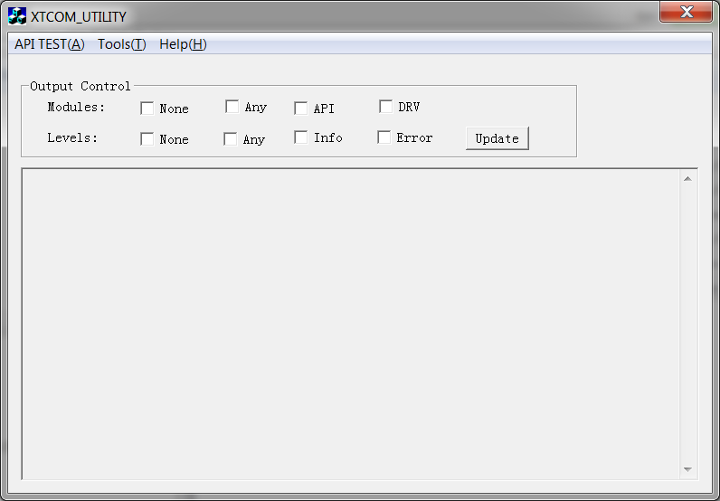
3. Hit *Tools -> Config Device* in the menu  
   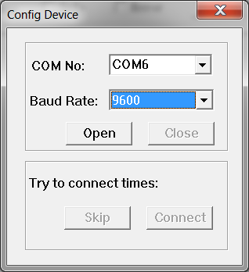
4. Configure the settings to whatever COM port you are using, and **9600** baud rate
5. Click on **"Open"**. You should receive a notification saying "Operation Succeeded!"
6. Click on **"Connect"**. The **"Try to connect times: "** message should increment a few times as the utility tries to contact the module.   
   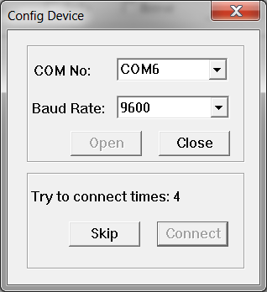  
   You should receive a notification about success before hitting **20** times.**If you don't, then make sure your connections are correct, and perhaps try swapping the RX and TX pins around.**
7. Close the "Config Device" window.
8. Hit *API TEST -> (4) Flash Image Download* in the menu  
   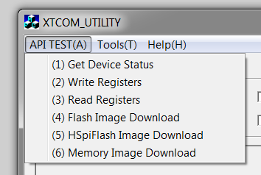
9. Select the **.bin** file to flash, and configure the correct destination address as in the **readme.txt** file *(****For Example:****boot_v1.1.bin @ 0x00000)*  
   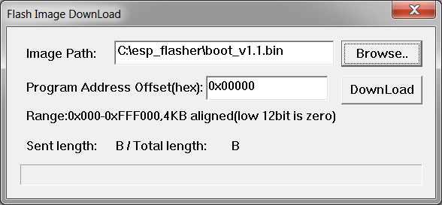
10. Click on **"Download"** and wait for the flashing to complete.
11. Close down the entire XTCOM_UTIL program, and unplug the USB. * **VERY IMPORTANT This must be done between each .bin file**
12. Repeat each of the above steps for each of the **.bin** files, making sure to leave the **GPIO0** pin grounded during the entire process.